**Projet BigData**

**Processing and storage of time series**

USER COMMAND

**Database**

**Spark RDD** 🡪 the database is save on local hdd

Table1(id, value)

Table2(id, value)

…

Table3(id, value)

**User Request :**

* OPEN database_name
* CLOSE
* SHOW
* DROP
* EXIST timeserie_name
* GET timeserie_name [ : variable_name_save]
* CREATE timeserie_name Schema [ : variable_name_save]

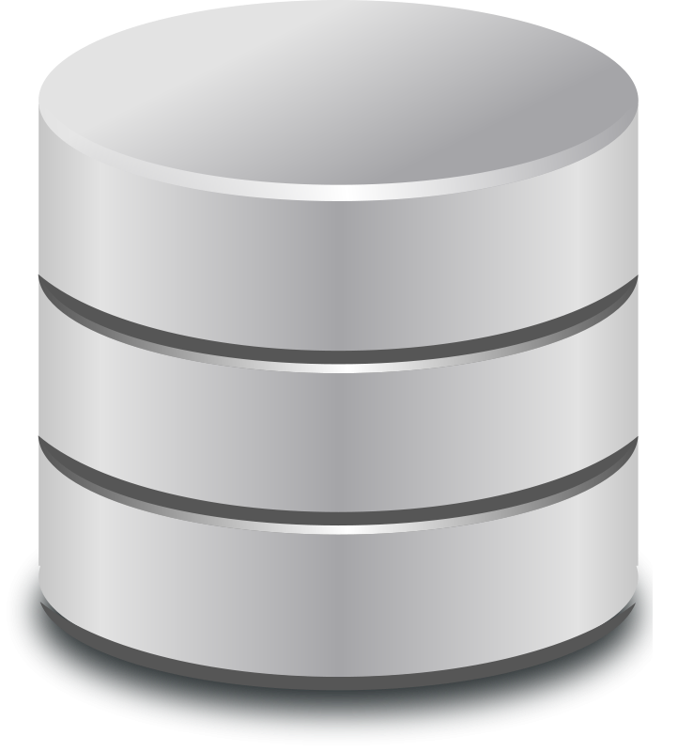

**Timeseries(name, Schema, Path, fileSystem, mode)**

**User Request:**

* CREATE_SCHEMA
* SHOW_SCHEMA timeserie_name
* GET_SCHEMA timeserie_name [ : variable_name_save ]
* SELECT_RANGE timeserie_name min_timestamp max_timestamp [ : variable_name_save ]
* MAX_VALUE timeserie_name
* MIN_VALUE timeserie_name
* MIN_TIMESTAMP timeserie_name
* MAX_TIMESTAMP timeserie_name

**Compression**

Indexing will work directly with storage 🡪 user will define

**User Request:**

* COMPRESSION parameter

**Indexing**

Indexing will work directly with storage 🡪 user will define

**User Request:**

* INDEXING parameter

**Transformation**

**User Request:**

* SQRT_TRANSFORM timeserie_name [ : variable_name_save]
* LOG_TRANSFORM timeserie_name [ : variable_name_save]
* MEAN timeserie_name
* SCALE timeserie_name [ : variable_name_save]
* STD_DEVIATION timeserie_name
* NORMALIZE timeserie_name [ : variable_name_save]
* SEARCH pattern timeserie_name
* MOVING_AVERAGE timeserie_name [ : variable_name_save]
* DTF timeserie_name [ : variable_name_save]
* DTW timeserie_name timeserie_name

**Standard command**

**User Request:**

* QUIT
* HELP
* VAR
* DEL variable_name
* RENAME variable_name new_name

**Forcasting (application)**

**User Request:**

* PERIODICITY timeserie_name [ : variable_name_save]
* FORCAST timeserie_name  [ : confidence_intervals ] [ :: number_of_time_units_to_forcast ]

**Clustering**

**User Request:**